Forest restoration: a global dataset for biodiversity and vegetation structure
Renato Crouzeilles^{1,2}*, Mariana S. Ferreira³ , and Michael Curran⁴

¹International Institute for Sustainability, Rio de Janeiro, RJ, 22460-320, Brasil
²Rio Conservation and Sustainability Science Centre, Department of Geography and the Environment, Pontifícia Universidade Católica, 22453900, Rio de Janeiro, Brazil.
³Laboratório de Vertebrados, Departament of Ecology, Universidade Federal do Rio de Janeiro, Rio de Janeiro, RJ, 68020, Brasil
⁴Group of Ecological Systems Design, Institute of Environmental Engineering, Swiss Federal Institute of Technology Zürich, 8093 Zürich, Switzerland
*Correspondence to: renatocrouzeilles@gmail.com

Introduction
More than 80% of the global land surface is under pressure from human activities. This has resulted in ongoing habitat loss and fragmentation and, consequently, decline in biodiversity, impairment of ecosystem services, and reduction in human well-being (MEA 2005, Fischer and Lindenmayer 2007). Because of these global environmental changes, ecological restoration is now a global priority (Aronson and Alexander 2013, Menz et al. 2013, Shackelford et al. 2013). Ecological restoration is the process of assisting and/or helping degraded, damaged, or destroyed ecosystems to recover from disturbances (SER 2004). The restoration of previously forested lands has been increasingly studied around the world (Clewell and Aronson 2007, Menz et al. 2013, Crouzeilles et al. 2016) and is supported by ambitious international targets, such as the Bonn Challenge, the New York Declaration of Forests, and the 20×20 Initiative. These initiatives/commitments seek to restore millions of hectares of degraded and disturbed forests in the coming decades with substantial projected socioeconomic benefits to humanity.
Billions of dollars have been spent on both ecological and landscape restoration of previously forested lands (Rey Benayas et al. 2009, Menz et al. 2013), but restoration outcomes differ widely among initiatives (Suding 2011). Some studies have shown that degraded ecosystems can naturally regenerate (passive restoration) in a few decades (e.g., Jones and Schmitz 2009), while others have shown the opposite trend (e.g., Liebsch et al. 2008), i.e., that restoration with human intervention is required (active restoration). It may occur because the appropriate restoration activity (passive or active) depends on both the landscape and local-scale context (e.g., Gibson et al. 2011, Leite et al. 2013, Crouzeilles et al. 2015). For example, the amount of forest cover in a landscape can affect where natural regeneration takes hold by acting as a source of propagules (Leite et al. 2013, Crouzeilles and Curran 2016), while the time elapsed since restoration started is a key local driver of forest restoration (Dunn 2004, Gardner et al. 2007, Martin et al. 2013, Curran et al. 2014, Cole et al. 2014, Crouzeilles et al. 2016). Thus, knowledge of both local ecological characteristics and landscape context of restoration initiatives are urgently required to guide further theoretical development and more cost-effective restoration initiatives on-the-ground (Rey Benayas et al. 2009, Crouzeilles et al. 2016).
To assist this aim, we compiled the most comprehensive global dataset gathered to date on forest restoration. It encompasses 269 primary studies across 221 study landscapes in 53 countries, and contains 4645 quantitative comparisons between reference ecosystems (e.g., old-growth forests) and restored or degraded ecosystems for five taxonomic groups (mammals, birds, invertebrates, herpetofauna, and plants) and five measures of vegetation structure reflecting different ecological processes (cover, density, height, biomass, and litter). Reference ecosystems were defined as old-growth or less-disturbed forests, restored ecosystems as selectively logged forests or forests in their initial or secondary stage of succession, and degraded ecosystems as different types of disturbance type (e.g., plantation or agriculture) that represents the initial degradation level; i.e., the starting point of the restoration process (Rey Benayas et al. 2009, Crouzeilles et al. 2016). Thus, this global dataset encompasses the full spectrum of the restoration process, from degraded to restored lands – what Gibson et al. (2011) called “disturbed ecosystems”. In addition, we estimated forest cover and three configuration metrics: (i) mean size of all forest patches, (ii) size of the largest forest patch, and (iii) edge:area ratio of forest patches, within three different buffer sizes around each study landscape using a recently developed 1 km consensus land cover dataset (Tuanmu and Jetz 2014). This global dataset on forest restoration is a valuable resource for theoretical research on both ecological and landscape restoration and also as a means of generating practical knowledge for restoration practitioners and stakeholders based on data across a wide range of taxonomic groups and measures of vegetation structure.

Metadata
Class I. Data set descriptors
A. Data set identity: Two files: Forest_restoration and References
Title: Forest restoration: a global dataset for biodiversity and vegetation structure
B. Data set and metadata identification codes:
Suggested Data Set Identity Codes: Forest_restoration.txt and References.xls
C. Data set description:
Principal Investigators:
Renato Crouzeilles
International Institute for Sustainability, Rio de Janeiro, RJ, 22460-320, Brazil and Rio Conservation and Sustainability Science Centre, Department of Geography and the Environment, Pontifícia Universidade Católica, 22453900, Rio de Janeiro, Brazil

Mariana Silva Ferreira
Laboratório de Vertebrados, Departament of Ecology, Universidade Federal do Rio de Janeiro, Rio de Janeiro, RJ, 68020, Brazil

Michael Curran
Group of Ecological Systems Design, Institute of Environmental Engineering, Swiss Federal Institute of Technology Zürich, 8093 Zürich, Switzerland

Abstract: Restoration initiatives are becoming increasingly applied around the world. Billions of dollars have been spent on ecological restoration research and initiatives, but restoration outcomes differ widely among these initiatives in part due to variable socioeconomic and ecological contexts. Here, we present the most comprehensive dataset gathered to date on forest restoration. It encompasses 269 primary studies across 221 study landscapes in 53 countries and contains 4645 quantitative comparisons between reference ecosystems (e.g., old-growth forest) and degraded or restored ecosystems for five taxonomic groups (mammals, birds, invertebrates, herpetofauna, and plants) and five measures of vegetation structure reflecting different ecological processes (cover, density, height, biomass, and litter). We selected studies that: (i) were conducted in forest ecosystems, (ii) had multiple, replicate sampling sites to measure indicators of biodiversity and/or vegetation structure in reference and restored and/or degraded ecosystems, and (iii) used less-disturbed forests as a reference to the ecosystem under study. We recorded: (i) latitude and longitude, (ii) study year, (iii) country, (iv) biogeographic realm,(v) past disturbance type, (vi) current disturbance type, (vii) forest conversion class, (viii) restoration activity, (ix) time that a system has been disturbed, (x) time elapsed since restoration started, (xi) ecological metric used to assess biodiversity, and (xii) quantitative value of the ecological metric of biodiversity and/or vegetation structure for reference and restored and/or degraded ecosystems. These were the most common data available in the selected studies. We also estimated forest cover and configuration in each study landscape using a recently developed 1 km consensus land cover dataset. We measured forest configuration as the: (i) mean size of all forest patches, (ii) size of the largest forest patch, and (iii) edge:area ratio of forest patches. Global analyses of the factors influencing ecological restoration success at both the local and landscape scale are urgently needed to guide restoration initiatives and to further develop restoration knowledge in a topic area of much contemporary interest.
D. Key words: amphibians; birds; ecological restoration; fragmentation index; invertebrates; landscape ecology; mammals; meta-analysis; reptiles; restoration success; species composition; vegetation structure.

Class II. Research origin descriptors
A. Overall project description
Identity: Forest restoration of biodiversity and vegetation structure
Originators: The project was coordinated by Renato Crouzeilles at the Universidade Federal do Rio de Janeiro, but currently at the International Institute for Sustainability/Rio Conservation and Sustainability Science Centre. Data were collected by Renato Crouzeilles, Mariana S. Ferreira and Michael Curran.
Period of Study: The period of study in the selected studies range from 1951 to 2010.
Objectives: The main aim of this study is to present the most comprehensive global database to date on forest restoration of biodiversity and vegetation structure. The data will be made available to the scientific community for further analyses of ecological restoration at the local and landscape scale. A number of timely issues and hypotheses regarding influential factors of ecological restoration can be addressed using this global dataset.
Abstract: Same as above.
Source(s) of funding: CAPES, FAPERJ (scholarships) to R.C., CAPES/FAPERJ/PAPD (scholarship) to M.S.F., and ETH Zürich (research grant CH1-0308-3) to M.C.
B. Specific subproject description
Site description: Our global dataset is focused in forest ecosystems. It includes six of the seven biogeographic realms proposed by Olson et al. (2001), i.e., this dataset represent different geographic regions across the world, excluding Antarctic.
Research Methods: We surveyed all quantitative studies compiled by seven key reviews of peer-reviewed scientific articles that included quantitative data of biodiversity recovery and/or forest succession in restored and/or degraded forest ecosystems in comparison to reference ecosystems (e.g., old-growth forests) (Dunn 2004, Ruiz-Jaen and Aide 2005, Bowen et al. 2007, Rey Benayas et al. 2009, Gibson et al. 2011, Wortley et al. 2013, Curran et al. 2014). We focused on screening the compiled studies by these reviews, rather than performing a new survey due to the large number of key words and combinations used in each review for literature search purposes (see Table 1). Despite the common focus on degraded and/or restored forest ecosystems, compiled studies differed among the reviews as a consequence of the key words in each literature search and inclusion criteria. It is important to note that the review of Curran et al. (2014) also included data of other reviews of secondary forest growth and ecological restoration (Brown and Lugo 1990, Houerou 2000, Gardner et al. 2007, Liebsch et al. 2008, Chazdon et al. 2009, Dent and Wright 2009, Jones and Schmitz 2009). We selected studies in the reference list of these seven reviews according to three main criteria: (i) conducted in forest ecosystems, (ii) with multiple, replicate sampling sites to measure indicators of biodiversity and/or vegetation structure in reference and restored and/or degraded ecosystems, and (iii) with reference forest as a benchmark for the restored or degraded ecosystem under consideration. Reference systems were defined as old-growth or less-disturbed forests, restored ecosystems as selectively logged forests or forests in their initial or secondary stage of succession, and degraded ecosystems as different types of disturbance (e.g., plantation or agriculture) that represents the initial degradation level: i.e., the starting point of the restoration process (Rey Benayas et al. 2009). The data from degraded ecosystems can enhance understanding of the process of forest restoration by helping to identify whether, and how, degraded ecosystems differ from restored ecosystems (i.e., as a negative control). Community data were gathered for biodiversity, because we were interested in the outcome of restoration for multiple species. A total of 269 studies were selected from a pool of: 33 studies compiled by Dunn (2004), 68 by Ruiz-Jaen and Aide (2005), 68 by Bowen et al. (2007), 89 by Rey Benayas et al. (2009), 138 by Gibson et al. (2011), 301 by Wortley et al. (2013), 108 by Curran et al. (2014), and another 16 additional studies that were suggested by specialists (the authors of Crouzeilles et al. 2016).

Table 1. The seven key reviews of passive and active restoration of either biodiversity or vegetation structure in degraded and/or restored forest ecosystems. Additional information is provided regarding the literature selection procedure for these reviews.
Review | Literature search/search period | Keywords/expressions | Criteria
(Dunn 2004) | Web of Science (1994–2001)  Cambridge Scientific Abstracts (1982–2001) | 1) Disturbance  2) Secondary Forest  3) Succession  4) Pasture  5) Logging | i) Clearcut logged sites but not selectively logged sites  ii) Species richness or species density  iii) Responses of focal taxa across a chronosequence of sites of known ages
(Ruiz-Jaen and Aide 2005) | Restoration Ecology (Vols. 1[1]–11[4]) | 1) All published papers | i) Only used seeding or planting techniques to assist the restoration process
(Bowen et al. 2007) | Web of Science (1990–2007) | 1) Habitat and  land abandon* or natural regrowth  2) Wildlife and  land abandon*  3) Habitat and  natural regrowth or native regrowth or natural regeneration or native regeneration | i) Articles published, peer reviewed and written in English  ii) Fauna occurrence, abundance, diversity or other estimates of occupancy in regrowth forest  iii) Fauna response to regrowth forests and mature forest or cleared land  iv) Prior cropping or grazing land use for at least one category of regrowth forest
(Rey Benayas et al. 2009) | Web of Science (up to 2008) | 1) Ecosystem or environment and service* or  function* and  restor* or  re-creat* or  rehabilitat* | i) Quantitative measures of variables related to provision of ecosystem services  ii) Quantitative measures of variables related to biodiversity  iii) Information on restored, reference and degraded systems  iv) Data on all three types of ecosystem services
(Gibson et al. 2011) | Web of Science  (1975–2010)  BIOSIS  (1975–2010) | 1) Bird*  or mammal*  or reptile*  or amphibia*  or arthropod*  or plants*  or lepidoptera*  or hymenoptera*  or arachnid*  or coleoptera*  or diptera*  or isoptera*  and clear-cutting*  or log*  or deforestation*  or fire*  or agriculture  or conversion*  or disturbance*  or degradation*  or secondary forest*  or plantation*  or fragment* | i) Measures of biodiversity at multiple sites in both primary and disturbed tropical forests  ii) Primary forests had little or no human disturbance  iii) Variance measures for biodiversity responses
(Wortley et al. 2013) | Web of Science  (up to 2012)  Ecological Restoration  Ecological Management and  Restoration | 1) Restoration  or restored and  eco* and  monitor*  or success*  or evaluat*  or assess* | i) Terrestrial ecological restoration  ii) Outcomes for restoration post-implementation  iii) Active restoration including planting, weed control, fire replacement, and soil amendment  iv) Excluded papers that only looked at the survival of plantings  v) Excluded papers that only looked at  restored site used for forestry production
(Curran et al. 2014) | Web of Science (up to 2009)  Previous reviews of:  Brown and Lugo (1990)  Houerou (2000)  Dunn (2004)  Bowen et al. (2007)  Liebsch et al. (2008)  Chazdon et al. (2009)  Jones and Schmitz (2009)  Dent and Wright (2009)  Rey Benayas et al. (2009)  Gardner et al. (2007) | 1) Biodiversity  or diversity  or species diversity  or species richness  and restor*  or reclamation  or regenerat*  or regrowth  or recover*  or sucession | i) Species diversity, abundance or occurrence of  secondary growth and old growth habitats  ii) Known age of the secondary growth habitat
Additional studies that were suggested by specialists (the authors of Crouzeilles et al. 2016)

Experimental/Sampling design: For each study, we recorded the following information: (i) latitude and longitude, (ii) study year, (iii) country, (iv) biogeographic realm,(v) past disturbance type, (vi) current disturbance type (for degraded ecosystems), (vii) forest conversion class (for restored ecosystems), (viii) restoration activity (for restored ecosystems), (ix) time that a system has been disturbed (for degraded ecosystems), (x) time elapsed since restoration started (for restored ecosystems), (xi) ecological metric used to assess biodiversity, and (xii) quantitative value of indicators of biodiversity and/or vegetation structure for reference and restored and/or degraded ecosystems. These were the most common data available in the selected studies.
Few studies had information at the landscape scale, thus we mapped forest cover within each study landscape using a recent 1-km resolution consensus land cover data set (Tuanmu and Jetz 2014). This dataset combines four existing land cover maps (DISCover 1995, GLC 2000, MODIS 2005, and ESA GlobCover 2008). It is more robust to temporal variation in land cover due to the agreement between land cover maps of different time periods. We chose the “reduced” dataset (Tuanmu and Jetz 2014), which excludes the DISCover product from 1995, because it was less influenced by land use change and deforestation pre-2000. This reduced dataset expressed proportional land cover (i.e., percentage area cover in each pixel) of 12 land cover types, with the summed value for all classes in each pixel equal to 100%. Because the highest resolution dataset (GlobCover 2008) had a resolution of 300 m, this land cover dataset could at best represent remnants of forest of 9 ha in size (i.e., 300 m × 300 m). Three of the 12 classes were continuous forest classes (evergreen/deciduous needleleaf trees, evergreen broadleaf trees, and deciduous broadleaf trees), which we combined into a single class by summing their respective cover values (giving a metric of forest cover ranging 0–100%). For further details, see Crouzeilles and Curran (2016).
We calculated two variations of percentage of forest cover within each study landscape: (i) considering all forest remnants ≥ 9 ha (overall forest cover), and (ii) only those pixels with a minimum percentage of 60% forest cover (contiguous forest cover). The percentage of forest cover for both maps (overall and contiguous) was estimated within each study landscape using eight different buffer sizes, ranging from 5 to 200 km radius, i.e., the landscape size ranged from 7854 to 12 566 400 ha. See Crouzeilles and Curran (2016) for further details about the: (i) database used for mapping forest areas, (ii) procedures to calculate the amount of forest area within each landscape, and (iii) scale of effect (i.e., optimal landscape buffer size) at which forest cover influences restoration success of biodiversity and vegetation structure (success was defined as a return to a benchmark/reference condition).
We also calculated four widely used metrics of habitat loss and fragmentation (Mcgarigal et al. 2002): (i) percentage of forest cover, (ii) mean size of all forest patches, (iii) size of largest forest patch, and (iv) edge:area ratio of forest patches. Thus, our database provided information about percentage of forest cover and configuration metrics at scales most plausible to explain mean forest restoration success of biodiversity and vegetation structure (landscape sizes of 100-, 10-, and 5-km radius) and for contiguous forest cover, which showed a stronger effect than overall forest cover on restoration success of biodiversity and vegetation structure (Crouzeilles and Curran 2016).

Class III. Data set status and accessibility
A. Status:
Latest update: 15 October 2015
Latest Archive date: 15 October 2015
Metadata status: 15 October 2015
Data verification: After Renato Crouzeilles and Mariana Silva Ferreira read through the title and abstract of all studies, potential candidates for inclusion in this dataset were assessed in detail by either Renato Crouzeilles, Mariana Silva Ferreira or Michael Curran.
B. Accessibility
Storage location and medium: Original data file exists on Renato Crouzeilles’ personal computer in MS Excel format and Text file format.
Contact person:
Renato Crouzeilles
International Institute for Sustainability, Rio de Janeiro, RJ, 22460-320, Brasil
Rio Conservation and Sustainability Science Centre, Department of Geography and the Environment, Pontifícia Universidade Católica, 22453900, Rio de Janeiro, Brazil
Email: renatocrouzeilles@gmail.com
Copyright restrictions: None.
Proprietary restrictions: None.
Costs: None. These data have been provided to multiple colleagues over the years at no cost; publication in Wiley Online is intended to promote dissemination of these data for scientific use, thus contributing to research on, and on-the-ground initiatives in, forest restoration.

Class IV. Data structural descriptors
A. Data Set File
Identity: Forest_restoration.txt
Size: 33 columns and 4,646 rows records, including header row.
Format and storage mode: Text file, tab-delimited, no compression.
Header information: Header names, variable definition (detailed description), units, storage type and notes.
Alphanumeric attributes: Mixed.
Special characters/fields: None.
B. Variable definitions: We assigned for each comparison between reference ecosystem and degraded or restored ecosystem an ID number. In addition, we assigned a number for each study and study landscape. We recorded in each study the following information: (i) latitude and longitude, (ii) study year, (iii) country, (iv) biogeographic realm, (v) past disturbance type, (vi) current disturbance type, (vii) forest conversion class, (viii) restoration activity, (ix) time that a system has been disturbed, (x) time elapsed since restoration started, (xi) landscape metrics of forest cover and fragmentation within each study landscape using three different buffer sizes of 100-, 10-, and 5-km radius – percentage of forest cover, mean size of all forest patches, size of largest forest patch, and edge:area ratio of forest patches, (xii) taxonomic group (mammals, birds, herpetofauna, invertebrates, and plants) and/or vegetation structure (density, litter, cover, biomass, and height), (xiii) ecological metric used to assess biodiversity, and (xiv) quantitative measure of biodiversity response and/or vegetation structure for reference and restored and/or degraded ecosystems. In the Forest_restoration.txt, “NA” means that no value or class was assigned for a variable because no information was available in the original study or it was not calculated for a landscape, while “-” means that no information should be assigned to this variable. For example, there is no restoration activity (Restoration_activity variable) for degraded ecosystems.

Variable name | Variable definition | Units | Storage type
ID | Individual identification number for each comparison of biodiversity or vegetation structure between restored or degraded and reference ecosystems. | N/A | Numeric
Study | Individual identification number for each study. | N/A | Numeric
Site | Individual identification number for each study landscape. It is possible to have more than one study in the same “study landscape”. | N/A | Numeric
Latitude | Geographic coordinates (latitude) for each study. When geographic coordinates were not available in the selected studies, we contacted the corresponding author by email. When multiple geographic coordinates were provided, we used the mean value to characterize the study landscape. Thus, geographic coordinates were located for each study in the center of the cluster of sampling sites. | Decimal degree | Numeric
Longitude | Geographic coordinates (longitude) for each study. When geographic coordinates were not available in the selected studies, we contacted the corresponding author by email. When multiple geographic coordinates were provided, we used the mean value to characterize the study landscape. Thus, geographic coordinates were located for each study in the center of the cluster of sampling sites. | Decimal degree | Numeric
Study_year | Year that the study was conducted. If the duration of the study was longer than one year, we used the mean year (rounded to nearest whole number). When this information was not available, we used the date at which the study was submitted. | Year | Numeric
Country | Country in which the study was conducted. | N/A | Character
Biogeographic_realm | Biogeographic realm in which the study was conducted (according to Olson et al. 2001). | N/A | Character
Past_disturbance_type | Current past disturbance type was classified as agriculture (represented by active or abandoned agriculture), burned, open, pasture, plantation, secondary logged, and selective logging. | N/A | Character
Disturbance_type | Current disturbance type was classified as agriculture, pasture, plantation, shaded plantation (e.g. agroforestry, cocoa and coffee plantations), and other (35% of which was burned forests), according to Gibson et al. (2011) and Crouzeilles et al. (2016). | N/A | Character
Forest_conversion | Forest conversion class was classified as secondary forest (completely or partially cleared forests that regenerated after disturbance ceased), and selectively logged forest, according to Gibson et al. (2011) and Crouzeilles et al. (2016). Gibson et al. (2011) suggests that selectively logged forests are largely affected by a single cutting cycle, while secondary forests can be affected by many cutting cycles, fire and/or other types of disturbance. Thus, secondary forests include selectively logged forests, but selective logging should be considered as a different type of forest conversion class that arose after disturbance ceased. | N/A | Character
Restoration_activity | Restoration activity was classified as passive regeneration, active management or planting (according to Crouzeilles et al. 2016). Passive regeneration is forest re-growth following land abandonment (including assisted restoration, e.g., fire and grazing protection); active management restoration represents manipulating disturbance regimes (for example, use of thinning and burning) and active planting represents plantation of tree species to influence the successional trajectory of recovery (e.g., Morrison and Lindell 2011, Holl and Aide 2011). | N/A | Character
Time_disturbed | Time that a system has been disturbed was measured in years (e.g., Dunn 2004, Martin et al. 2013, Curran et al. 2014, Cole et al. 2014). A higher value means a longer disturbance period. | Years | Numeric
Time_restored | Time elapsed since restoration started was measured in years (e.g., Dunn 2004, Martin et al. 2013, Curran et al. 2014, Cole et al. 2014, Crouzeilles et al. 2016). A higher value means a longer restoration time. | Years | Numeric
Cover_100 | Percentage of contiguous forest cover within a landscape size of 100-km radius around the study site. | Percentage | Numeric
LPS_100 | Largest forest patch size within a landscape size of 100-km radius around the study site. | Square kilometers | Numeric
MPS_ 100 | Mean forest patch size within a landscape size of 100-km radius around the study site. | Square kilometers | Numeric
Edge_100 | Edge:area ratio of forest patches within a landscape size of 100-km radius around the study site. | Ratio | Numeric
Cover_10 | Percentage of contiguous forest cover within a landscape size of 10-km radius around the study site. | Percentage | Numeric
LPS_10 | Largest forest patch size within a landscape size of 10-km radius around the study site. | Square kilometers | Numeric
MPS_ 10 | Mean forest patch size within a landscape size of 10-km radius around the study site. | Square kilometers | Numeric
Edge_10 | Edge:area ratio of forest patches within a landscape size of 10-km radius around the study site. | Ratio | Numeric
Cover_5 | Percentage of contiguous forest cover within a landscape size of 5-km radius around the study site. | Percentage | Numeric
LPS_5 | Largest forest patch size within a landscape size of 5-km radius around the study site. | Square kilometers | Numeric
MPS_ 5 | Mean forest patch size within a landscape size of 5-km radius around the study site. | Square kilometers | Numeric
Edge_5 | Edge:area ratio of forest patches within a landscape size of 5-km radius around the study site. | Ratio | Numeric
Taxonomic_group | Taxonomic group reported (Plants, Invertebrates, Birds, Mammals, or Herpetofauna). | N/A | Numeric
Vegetation_structure | Measure of vegetation structure reported (Cover, Density, Height, Litter, or Biomass). | N/A | Numeric
Ecological_metric | Ecological metrics were classified as abundance (e.g., number, proportion, frequency and density of individuals, equitability, capture rates, captures per effort time), richness (e.g., observed, estimated, rarefied, genera, family and guild richness, species density), diversity (e.g., Shannon index, Simpson index, Margalef index, Fisher alpha, evenness), species similarity (e.g., Sorenson index, Morisita-Horn index, ANOSIM, PCA, MDS, Mantel, Jaccard index, Bray Curtis and Euclidean distances), or others (e.g., colonization, extinction, visitor, encounter and removal seed rates, fruit production, recruitment, proportion of traits per state). | N/A | Character
Restored | Quantitative measure of biodiversity response or vegetation structure for restored ecosystems. We defined restored ecosystems as selectively logged forests or forests in their initial or secondary stage of succession. | N/A | Numeric
Degraded | Quantitative measure of biodiversity response or vegetation structure for degraded ecosystems. We defined degraded ecosystems as different types of disturbance type (e.g., plantation or agriculture), which measures the initial degradation level – i.e., the starting point of the restoration process (Rey Benayas et al. 2009, Crouzeilles et al. 2016). | N/A | Numeric
Reference | Quantitative measure of biodiversity response or vegetation structure for reference ecosystems. We defined reference ecosystems as old-growth or less-disturbed forests (e.g., Crouzeilles et al. 2016). | N/A | Numeric

C. Data limitations. Our dataset has four main limitations: (i) we selected studies carried out in forest ecosystems only, (ii) we focused on the ecological aspects rather than socioeconomic aspects of forest restoration, (iii) we collected the most common ecological data available in the selected studies, i.e., other less recognized ecological variables that may affect forest restoration were not gathered, and (iv) the coarse spatial resolution of the land cover data and variability in the biodiversity/vegetation structure data.

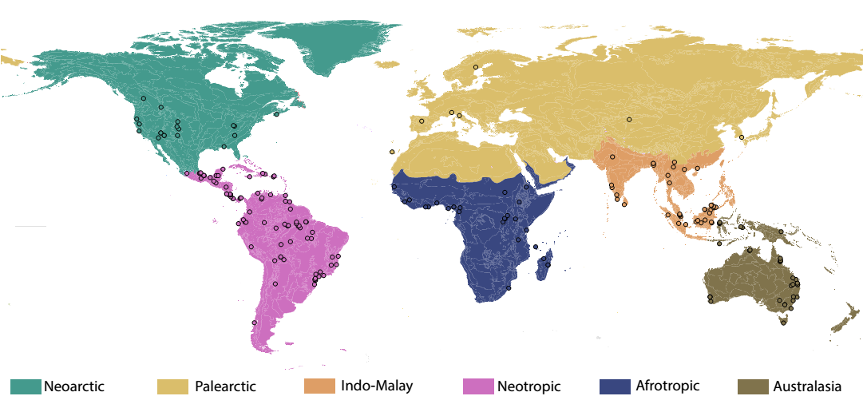
Figure 1. Biogeographical realm in which the study was conducted (according to Olson et al. 2001). In total, we considered 221 study landscapes, but 11 were not represented because of the lack of information on their location.
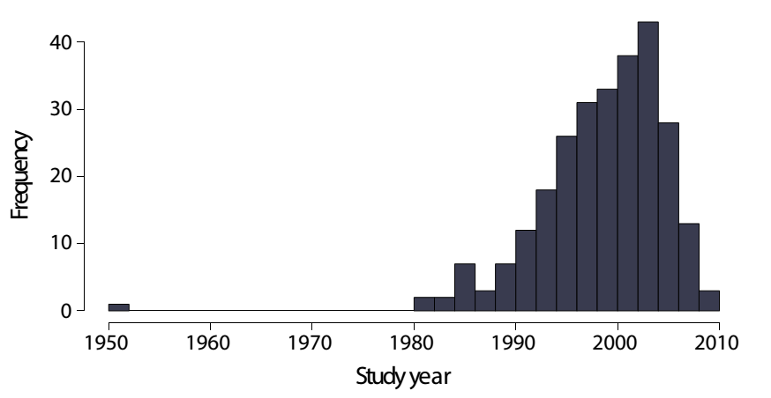
Figure 2. Frequency of studies per year (n = 269).

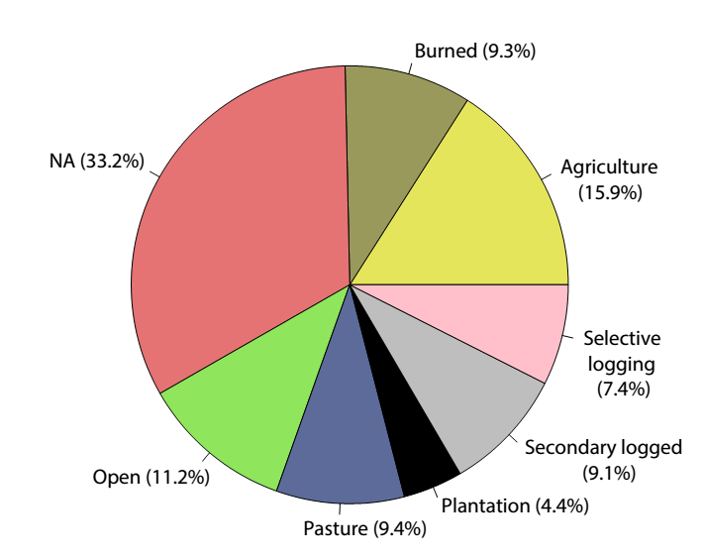
Figure 3. Past disturbance type for the 4,645 comparisons between reference and degraded or restored ecosystems, respectively. Past disturbance type was classified as agriculture, burned, open, pasture, plantation, secondary logged, and selective logging. “NA” means that no class was assigned because no information was available in the original study.

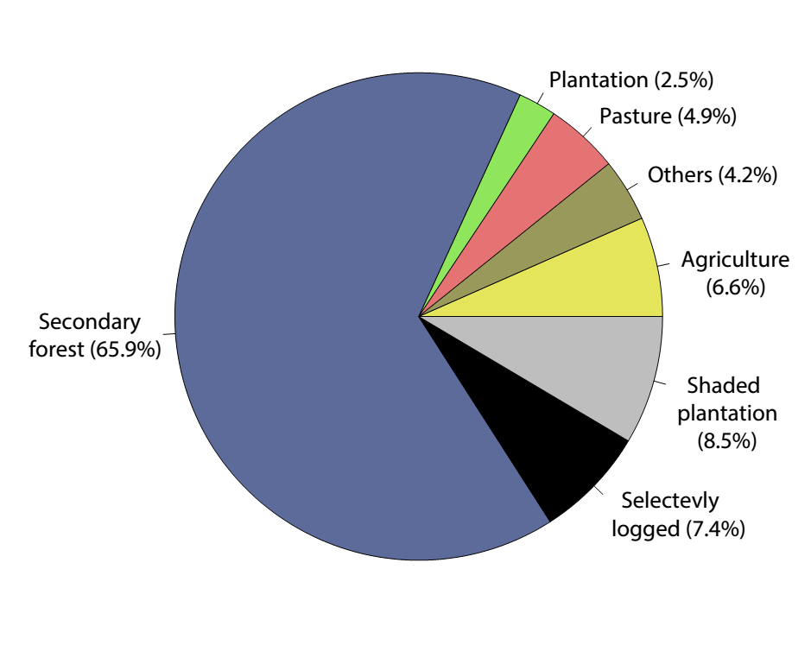
Figure 4. Disturbance type and forest conversion classes for the 4,645 comparisons between reference and degraded or restored ecosystems, respectively. Disturbance type was classified as agriculture, pasture, plantation, shaded plantation, and other. Forest conversion class was classified as secondary forest and selectively logged forests.

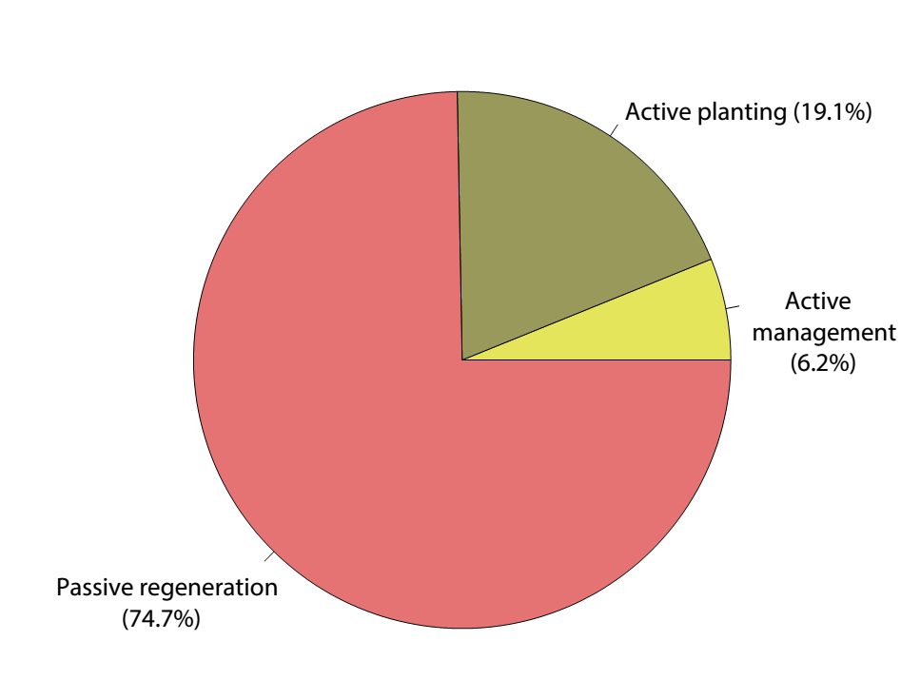
Figure 5. Restoration activities for the 3736 comparisons between reference and restored ecosystems. Restoration activity was classified as passive regeneration, active management, or active planting.

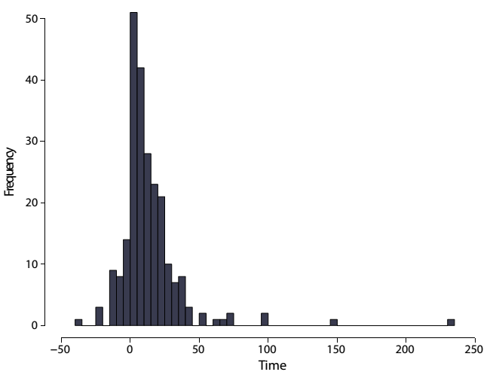
Figure 6. Time that a system has been disturbed or the time elapsed since restoration started (in years) for the 4645 comparisons between reference and degraded or restored forest, respectively. To produce the figure, we use negative values for the time that a system has been disturbed (i.e., a higher negative value means more time a system has been degraded), and positive values for the time elapsed since restoration started (i.e., a higher positive value means more time a system has been restored).
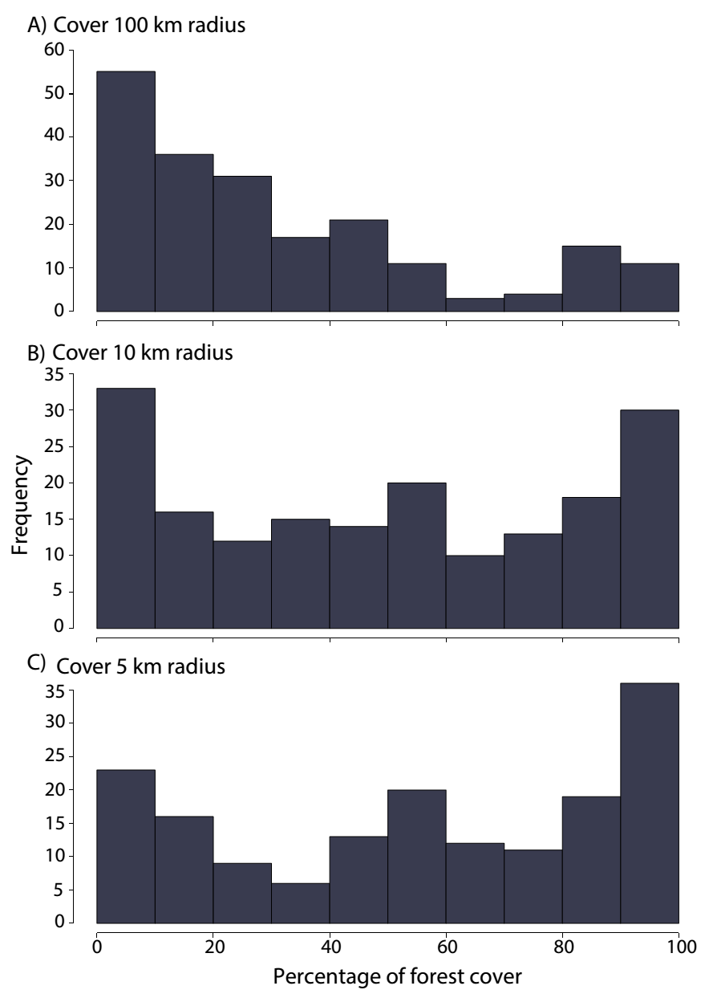
Figure 7. Frequency of the percentage of contiguous forest cover within a landscape size of (A) 100-, (B) 10-, and (C) 5-km radius for the 221 study landscapes. Eleven study landscapes were not represented because of the lack of information on their location.

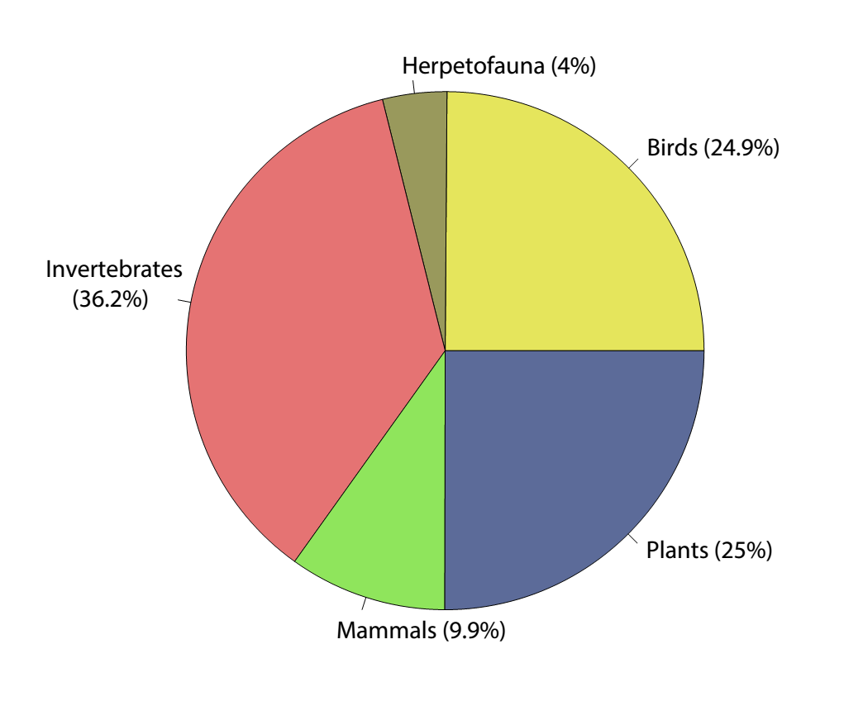
Figure 8. Biodiversity reported for the 3765 comparisons between reference and degraded or restored ecosystems. Taxonomic groups were classified as plants, invertebrates, birds, mammals, and herpetofauna.

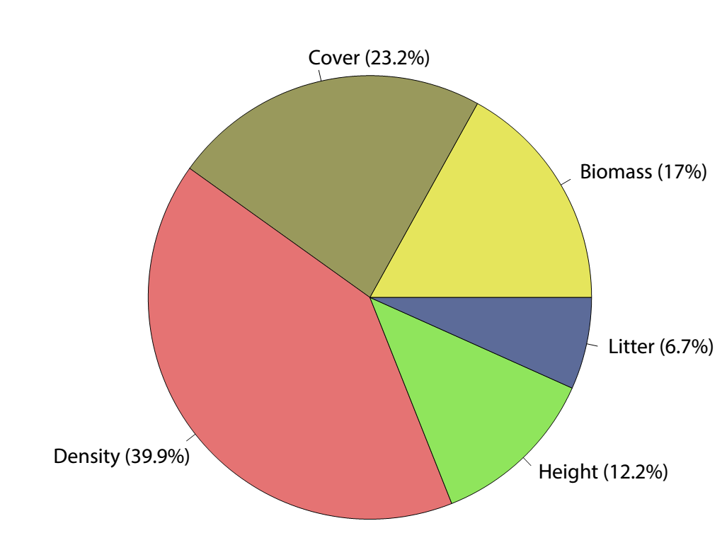
Figure 9. Vegetation structure reported for the 880 comparisons between reference and degraded or restored ecosystems. Measures of vegetation structure were classified as biomass, cover, density, height, and litter.

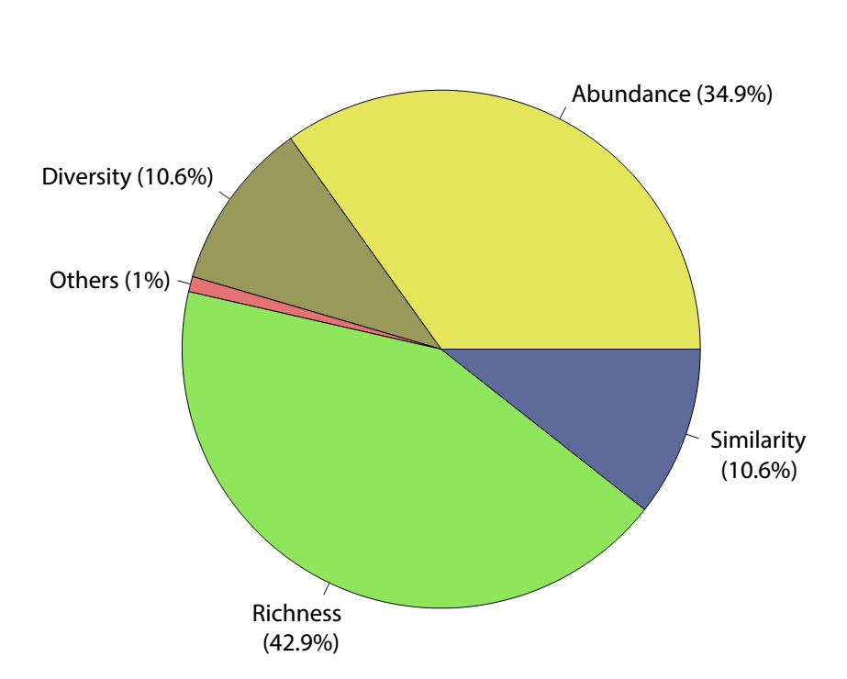
Figure 10. Ecological metrics reported for the 3765 biodiversity comparisons between reference and degraded or restored ecosystems. Ecological metrics were classified as abundance, richness, diversity, species similarity, and others (e.g., colonization, extinction, visitor, encounter and removal seed rates, fruit production, recruitment, proportion of traits per state).

Class V. Supplemental descriptors
A. Data set references
Aronson, J., and S. Alexander. 2013. Ecosystem restoration is now a global priority: Time to roll up our sleeves. Restoration Ecology 21:293–296.
Bowen, M. E., C. A. McAlpine, A. P. N. House, and G. C. Smith. 2007. Regrowth forests on abandoned agricultural land: A review of their habitat values for recovering forest fauna. Biological Conservation 140:273–296.
Brown, S., and A. E. Lugo. 1990. Tropical Secondary Forests. Journal of Tropical Ecology 6:1–32.
Chazdon, R. L., C. A. Peres, D. Dent, D. Scheil, A. E. Lugo, D. Lamb, N. E. Stork, and S. E. Miller. 2009. The potential for species conservation in tropical secondary forests. Conservation Biology 23:1406–1417.
Clewell, A. F., and J. Aronson. 2007. Ecological restoration: principles, values, and structure of an emerging profession. Island Press, Washington.
Cole, L. E. S., S. A. Bhagwat, and K. J. Willis. 2014. Recovery and resilience of tropical forests after disturbance. Nature communications 5:3906.
Crouzeilles, R., H. L. Beyer, M. Mills, C. E. V Grelle, and H. P. Possingham. 2015. Incorporating habitat availability into systematic planning for restoration: a species-specific approach for Atlantic Forest mammals. Diversity and Distributions 21:1027–1037.
Crouzeilles, R., and M. Curran. 2016 Which landscape size best predict the influence of forest cover on restoration success? A global meta-analysis on the scale of effect. Journal of Applied Ecology 53:440–448.
Crouzeilles, R., M. Curran, M. S. Ferreira, D. B. Lindenmayer, C. E. V. Grelle, and J. M. Rey Benayas. 2016 A global meta-analysis on the ecological drivers of forest restoration success DOI:10.1038/ncomms11666.
Curran, M., S. Hellweg, and J. Beck. 2014. Is there any empirical support for biodiversity offset policy? Ecological Applications 24:617–631.
Dent, D. H., and S. J. Wright. 2009. The future of tropical species in secondary forests: a quantitative review. Biological Conservation 142:2833–2843.
Dunn, R. R. 2004. Recovery of Faunal Communities During Tropical Forest Regeneration. Conservation Biology 18:302–309.
Fischer, J., and D. B. Lindenmayer. 2007. Landscape modification and habitat fragmentation: a synthesis. Global Ecology and Biogeography 16:265–280.
Gardner, T. A., J. Barlow, L. W. Parry, and C. A. Peres. 2007. Predicting the uncertain future of Tropical Forest species in a data vacuum. Biotropica 39:25–30.
Gibson, L., T. M. Lee, L. P. Koh, B. W. Brook, T. A. Gardner, J. Barlow, C. A. Peres, C. J. A. Bradshaw, W. F. Laurance, T. E. Lovejoy, and N. S. Sodhi. 2011. Primary forests are irreplaceable for sustaining tropical biodiversity. Nature 478:378–381.
Holl, K. D., and T. M. Aide. 2011. When and where to actively restore ecosystems? Forest Ecology and Management 261:1558–1563.
Houerou, H. N. L. 2000. Restoration and rehabilitation of arid and semiarid Mediterranean ecosystems in North Africa and West Asia: a review. Arid Land Research and Management 14:3–14.
Jones, H. P., and O. J. Schmitz. 2009. Rapid Recovery of Damaged Ecosystems. PloS one 4:e5653.
Leite, M. de S., L. R. Tambosi, I. Romitelli, and J. P. Metzger. 2013. Landscape ecology perspective in restoration projects for biodiversity conservation: a Review. Natureza & Conservação 11:108–118.
Liebsch, D., M. C. M. Marques, and R. Goldenberg. 2008. How long does the Atlantic Rain Forest take to recover after a disturbance? Changes in species composition and ecological features during secondary succession. Biological Conservation 141:1717–1725.
Martin, P. A., A. C. Newton, and J. M. Bullock. 2013. Carbon pools recover more quickly than plant biodiversity in tropical secondary forests. Proceedings of the Royal Society B 280:20132236.
Mcgarigal, K., S. Cushman, M. Neel, and E. Ene. 2002. FRAGSTATS: Spatial pattern analysis program for categorical maps.
Menz, M. H. M., K. W. Dixon, and R. J. Hobbs. 2013. Hurdles and opportunities for landscape-scale restoration. Science 339:526–527.
Millennium Ecosystem Assessment. 2005. Ecosystems and human well-being: Biodiversity synthesis. Washington.
Morrison, E. B., and C. A. Lindell. 2011. Active or passive forest restoration? Assessing restoration alternatives with avian foraging behavior. Restoration Ecology 19:170–177.
Olson, D. M., N. D. Dinerstein, E Wikramanayak, E D Burgess, E. C. Powell, G V N Underwood, J. A. D’amico, I. Itoua, H. E. Strand, J. C. Morrison, C. J. Loucks, T. F. Allnutt, T. H. Ricketts, Y. Kura, J. F. Lamoreux, W. W. Wettengel, P. Hedao, and K. R. Kassem. 2001. Terrestrial ecoregions of the world: a new map of life on earth. BioScience 51:933.
Rey Benayas, J. M., A. C. Newton, A. Diaz, and J. M. Bullock. 2009. Enhancement of biodiversity and ecosystem services by ecological restoration: a meta-analysis. Science 325:1121–1124.
Ruiz-Jaen, M. C., and T. Aide. 2005. Restoration success: how is it being measured? Restoration Ecology 13:569–577.
Shackelford, N., R. J. Hobbs, J. M. Burgar, T. E. Erickson, J. B. Fontaine, E. Laliberté, C. E. Ramalho, M. P. Perring, and R. J. Standish. 2013. Primed for Change: Developing Ecological Restoration for the 21st Century. Restoration Ecology 21:297–304.
Suding, K. N. 2011. Toward an era of restoration in ecology: Successes, failures, and opportunities ahead. Annual Review of Ecology, Evolution, and Systematics 42:465–487.
Tuanmu, M. N., and W. Jetz. 2014. A global 1-km consensus land-cover product for biodiversity and ecosystem modelling. Global Ecology and Biogeography 23:1031–1045.
Wortley, L., J.-M. Hero, and M. Howes. 2013. Evaluating ecological restoration success: A review of the literature. Restoration Ecology 21:537–543.

